Game differences

# Splash Screen

## Original Intentions

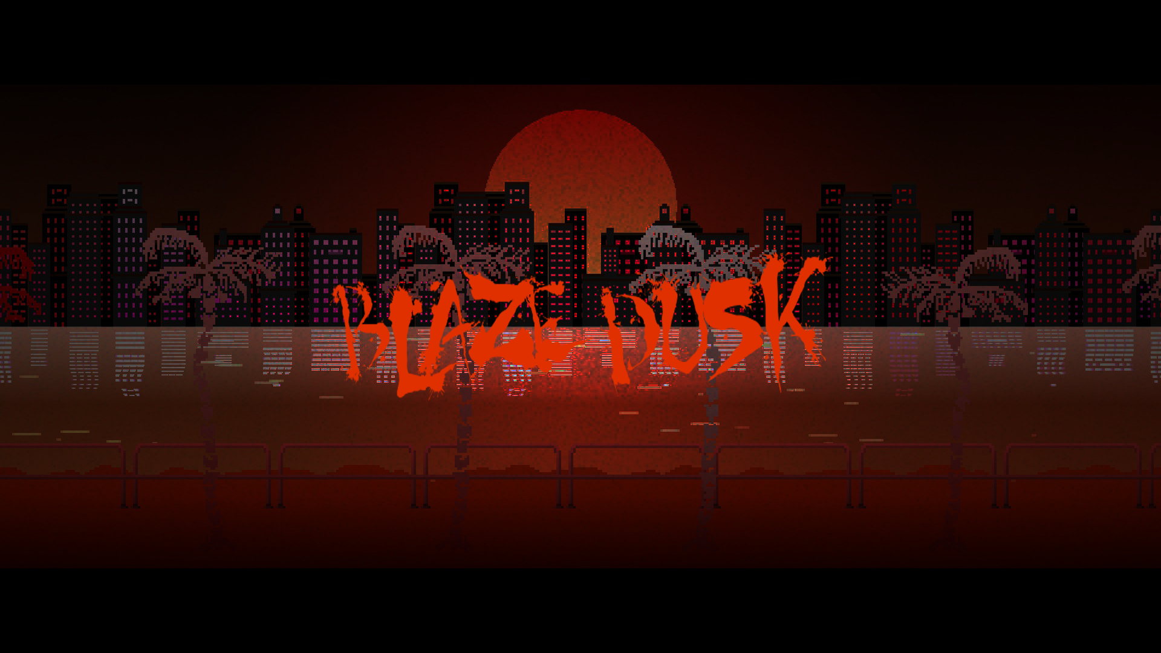

## Final Product

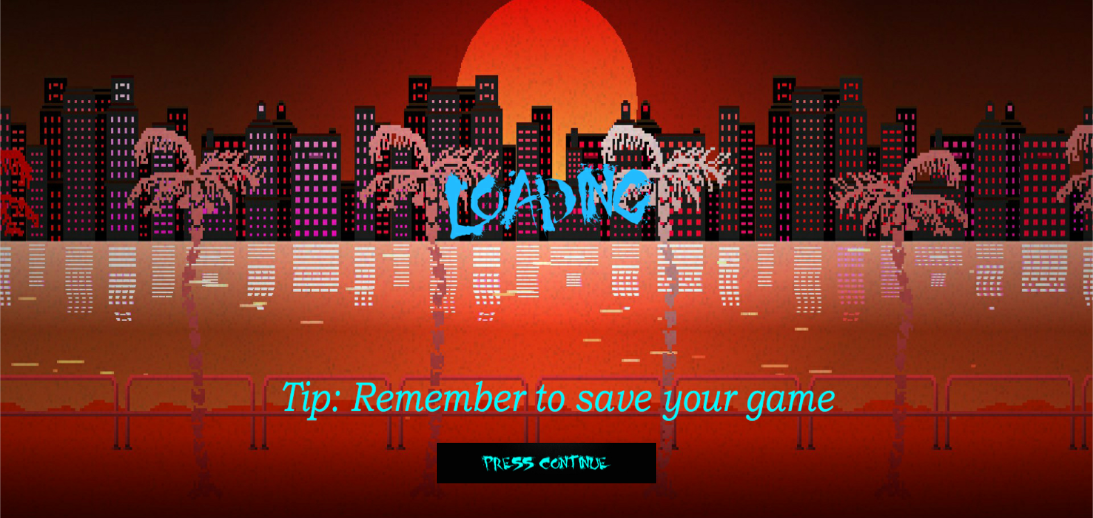

# Main Menu

## Original Intentions

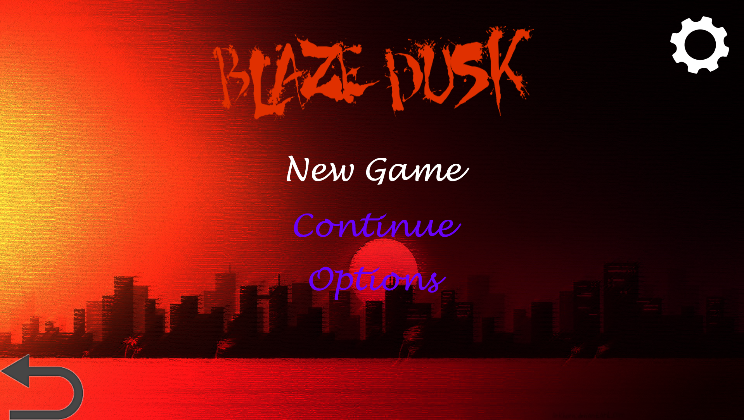

## Final Product

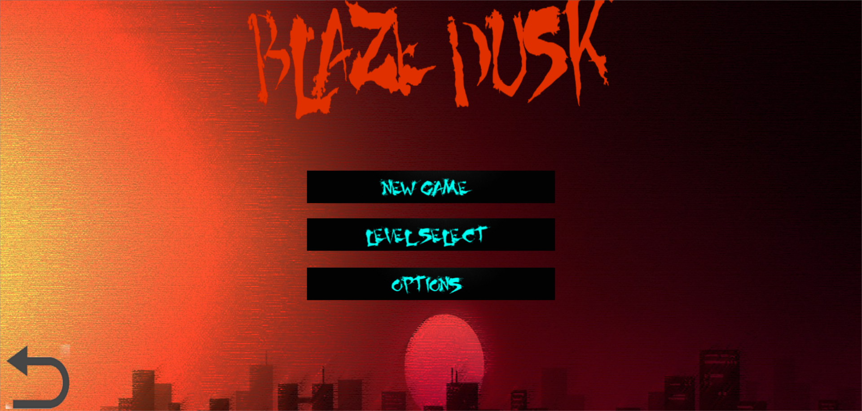

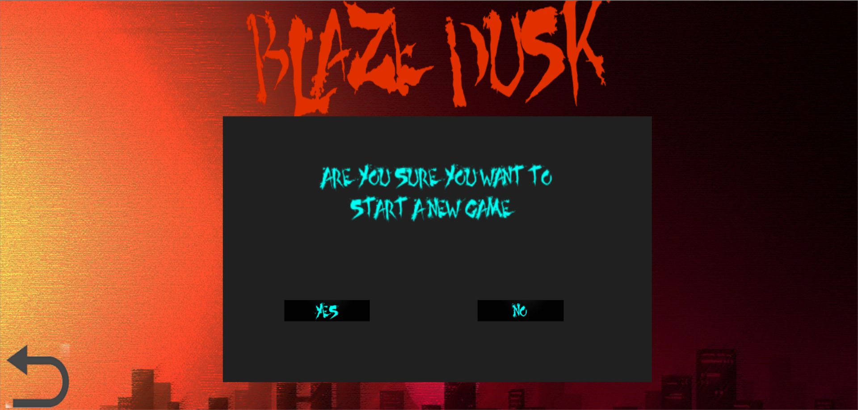

# Game Over Screen

## Original Intentions

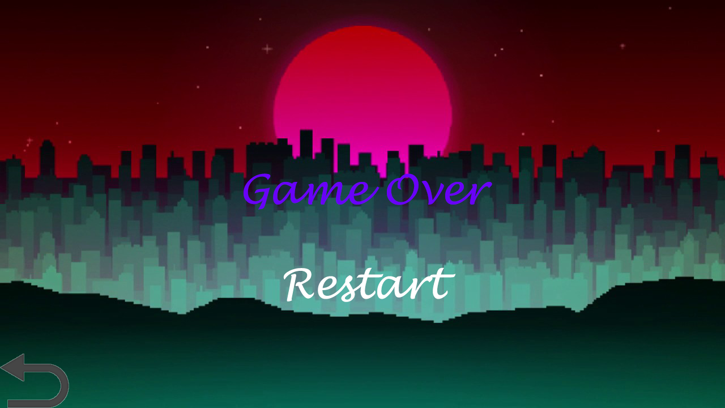

## Final Product

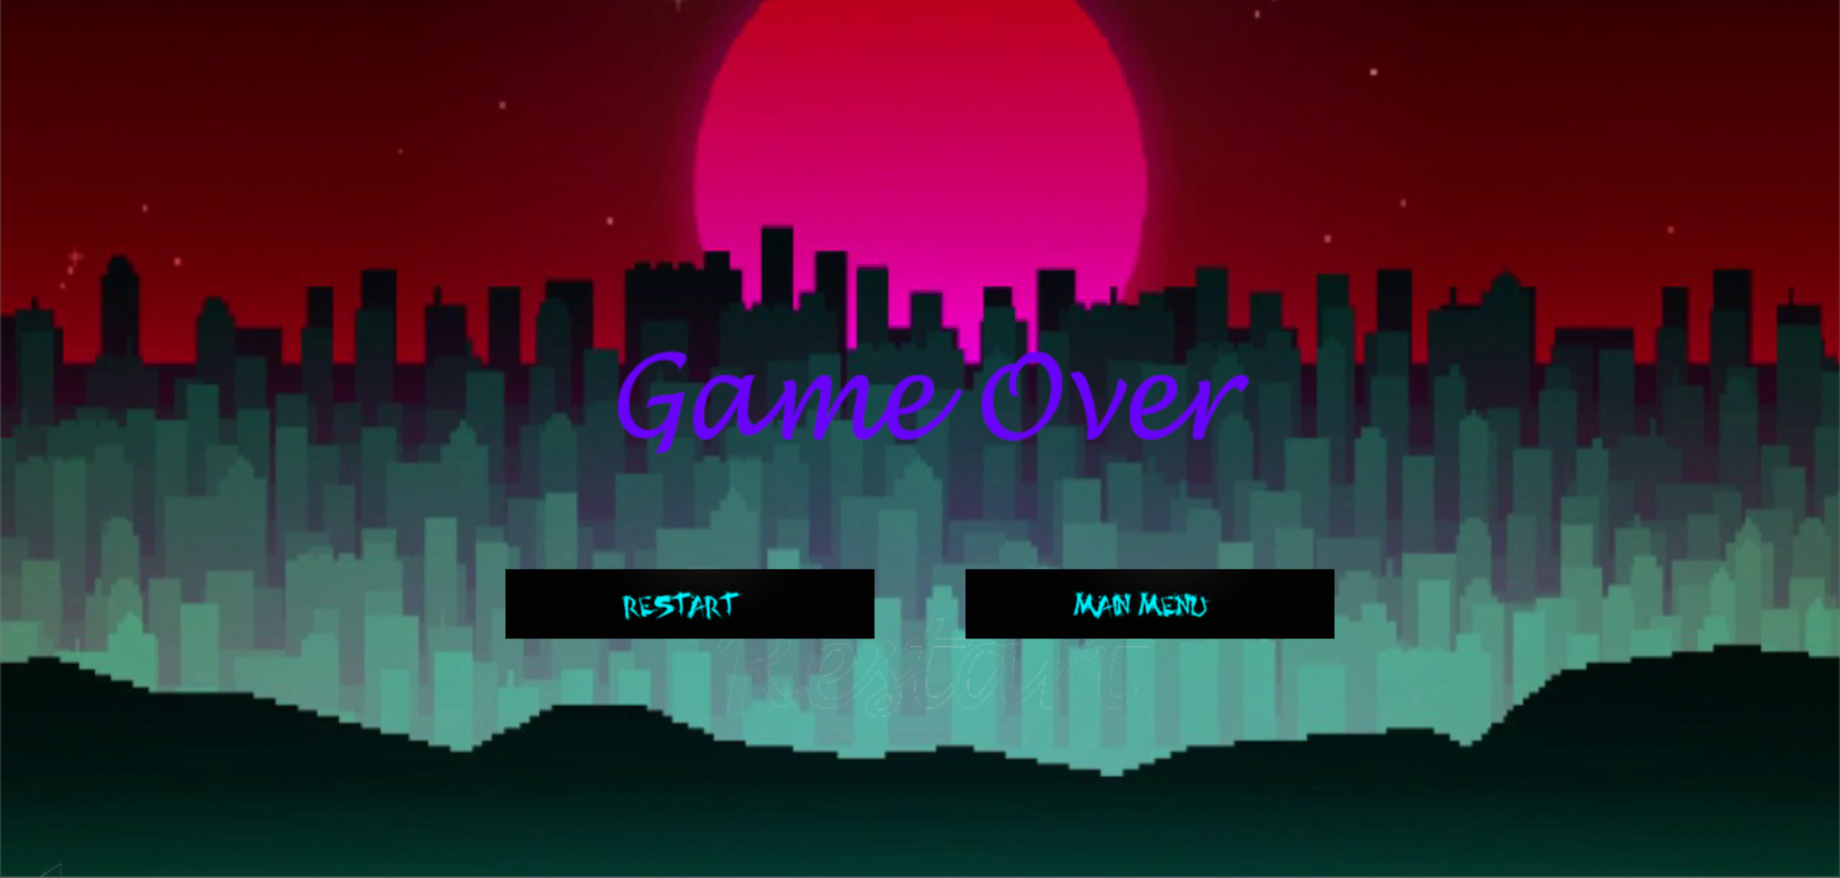

# Option Screen

## Original Intentions

## 

## Final Product

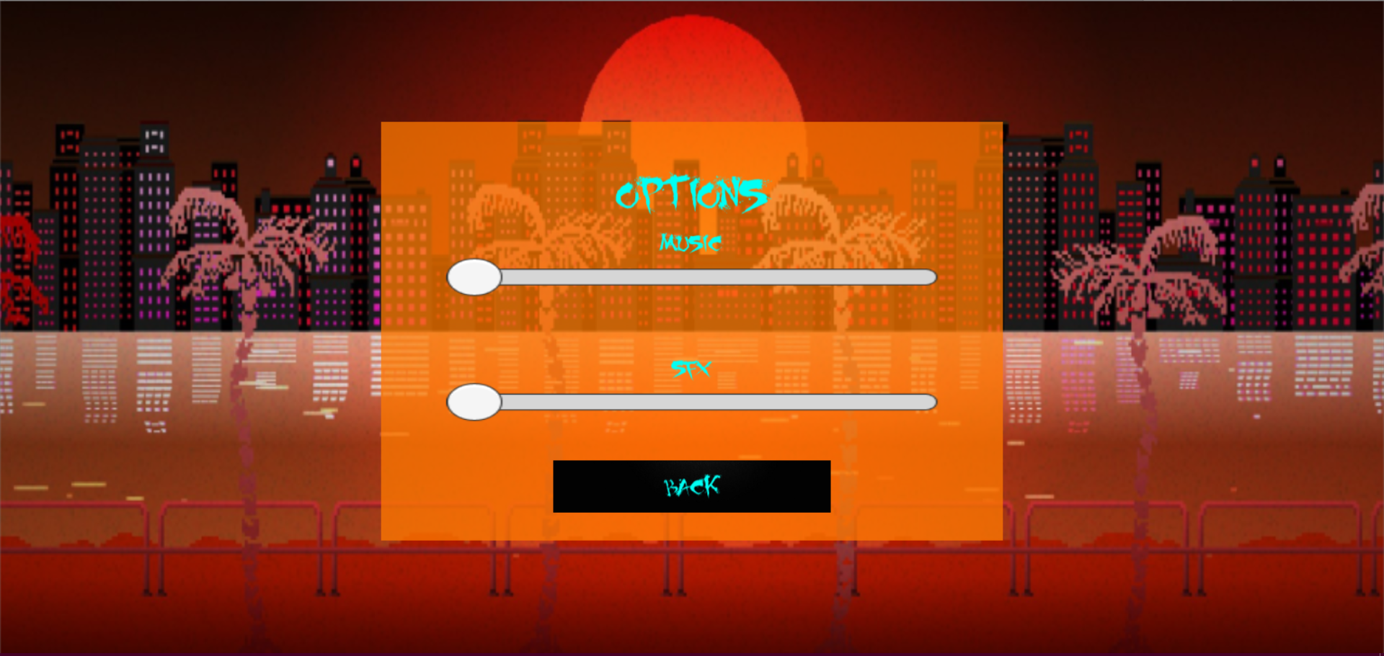

# Level Selection Screen

## Original Intentions

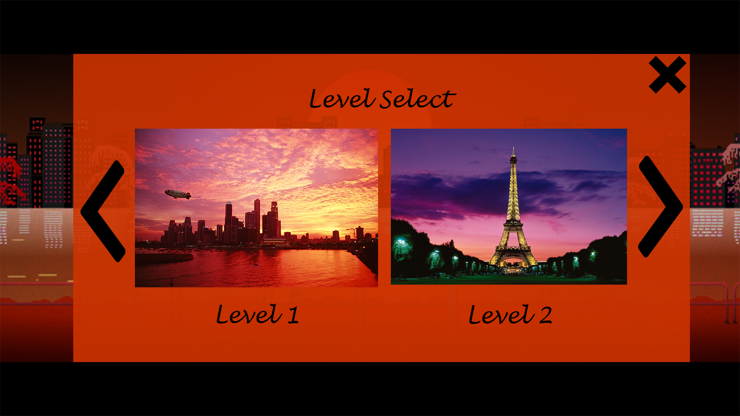

## Final Product

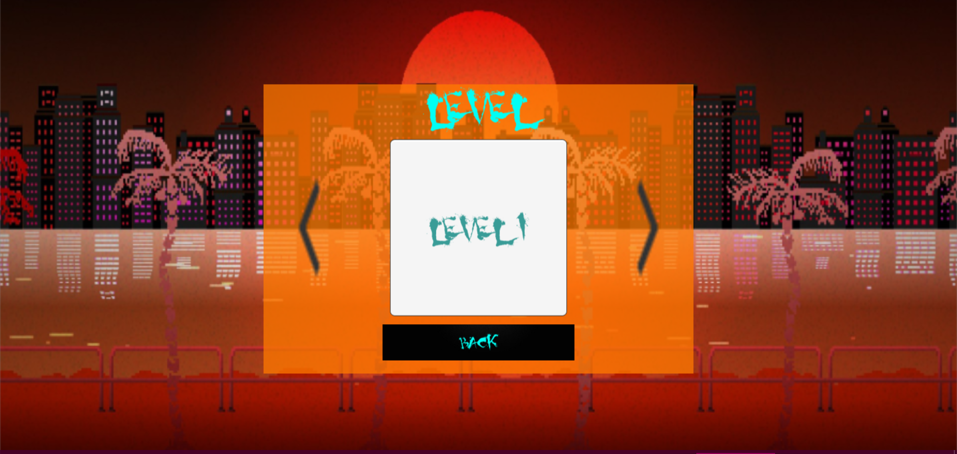

# Game Screen

## Original Intentions

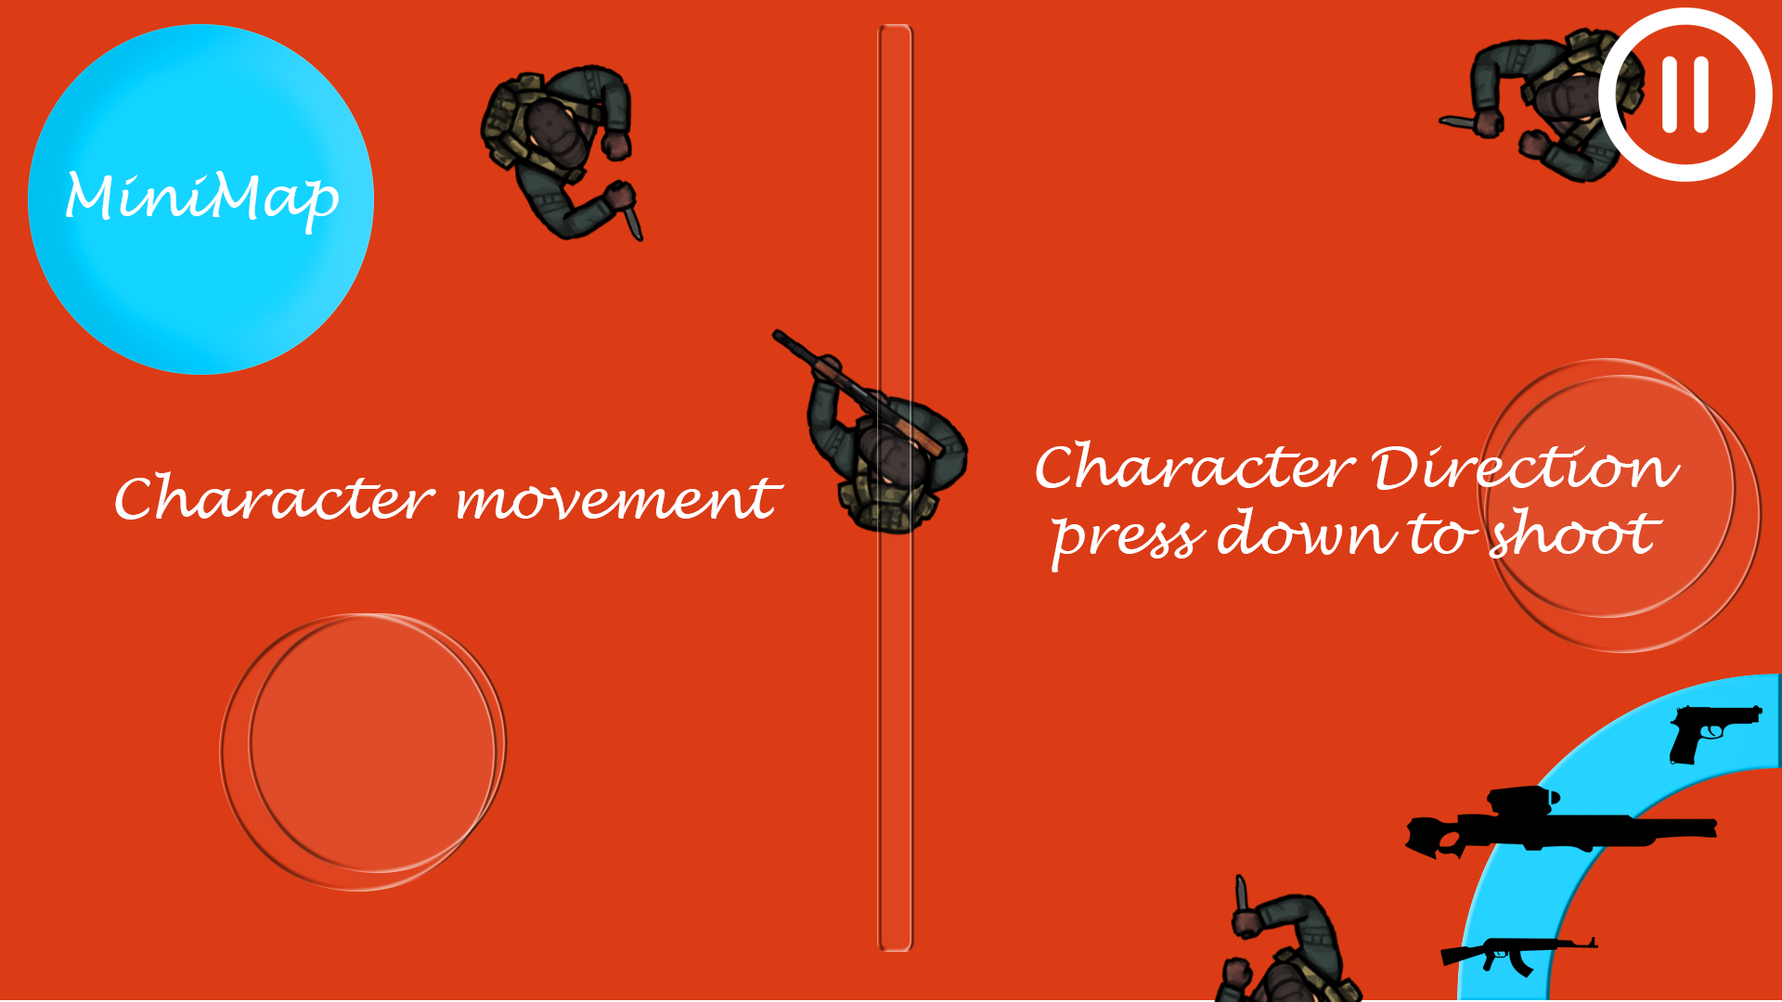

## Final Product

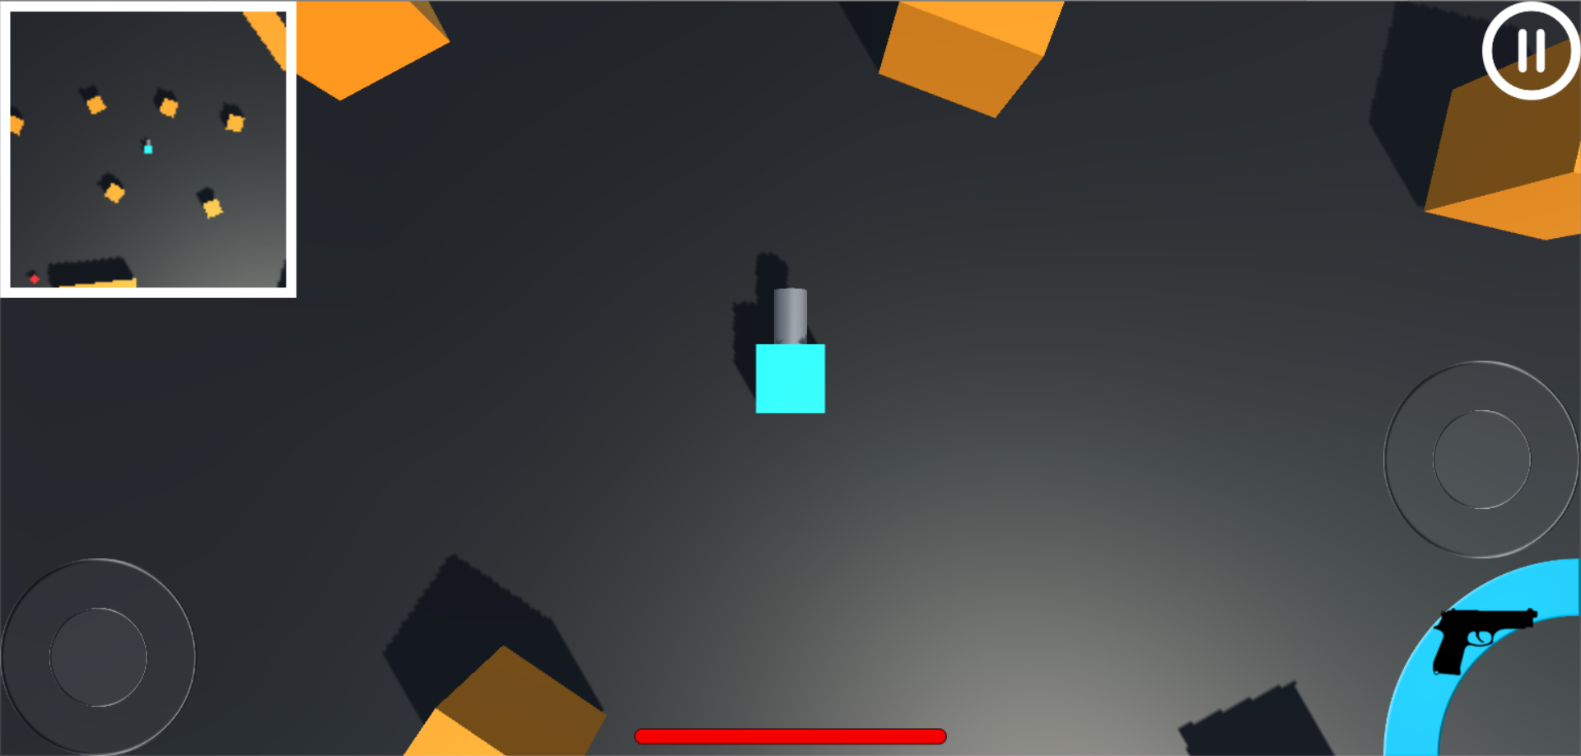

# Notes

* Screens not implemented are **Loading screen** and **Upgrade screen**.
* After our first presentation, we heed to the advices given to us and standardize our UI to look similar to each other so that it will look like one game.
* All our buttons have a white text when on touch and has a black color background to show the player the size of the button where they can touch on.